**How to push the code from VS Code to Github?**

* Go to “Visual studio Code” [ in PW Skills open flask template]

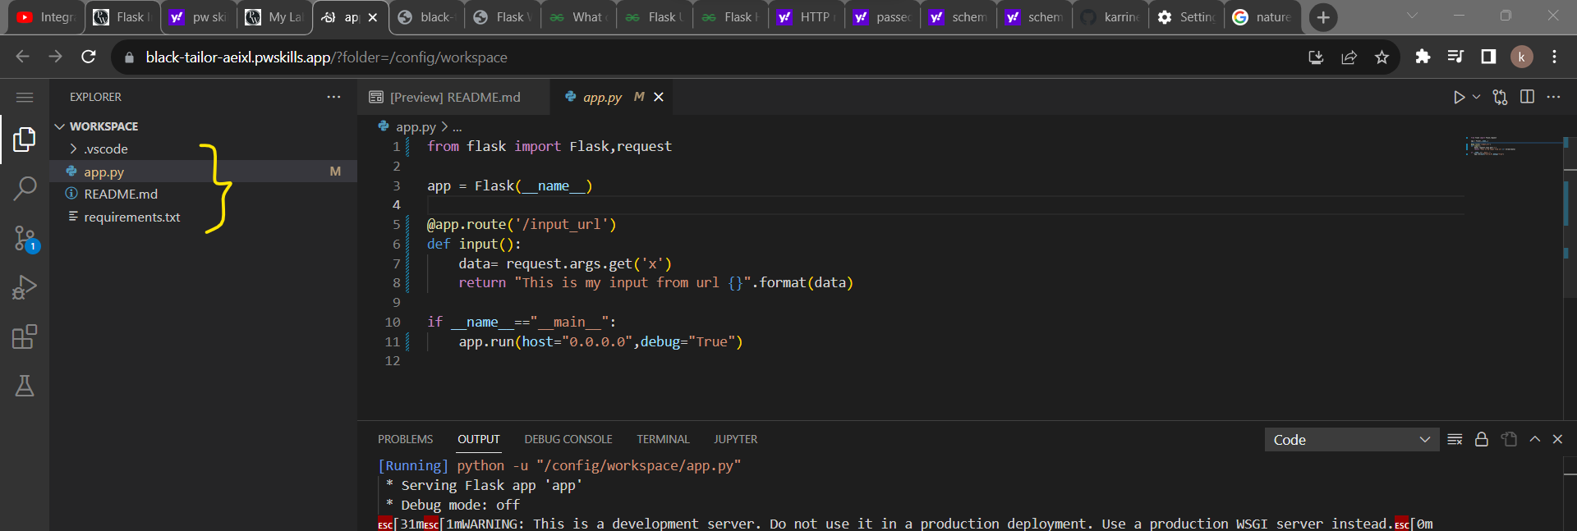

* As you can see from the above screenshot, we have some files like app.py, README.md, requirements.txt
* Now we can push all these files by executing some commands in **terminal**.
* Pre-requisite to push all the files from VS Code to Github:

1. Create a new git hub repository to where you want to push all these files.
2. The created repository must be “Public”

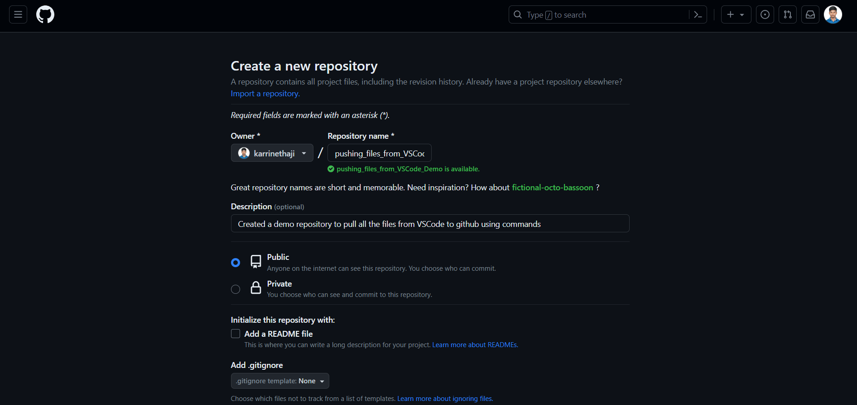

Name of the repository: pushing_files_from_VSCode_Demo

Visibility: Public

Click on “**Create Repository**”

After creating the Git Hub repository, it will show as below:

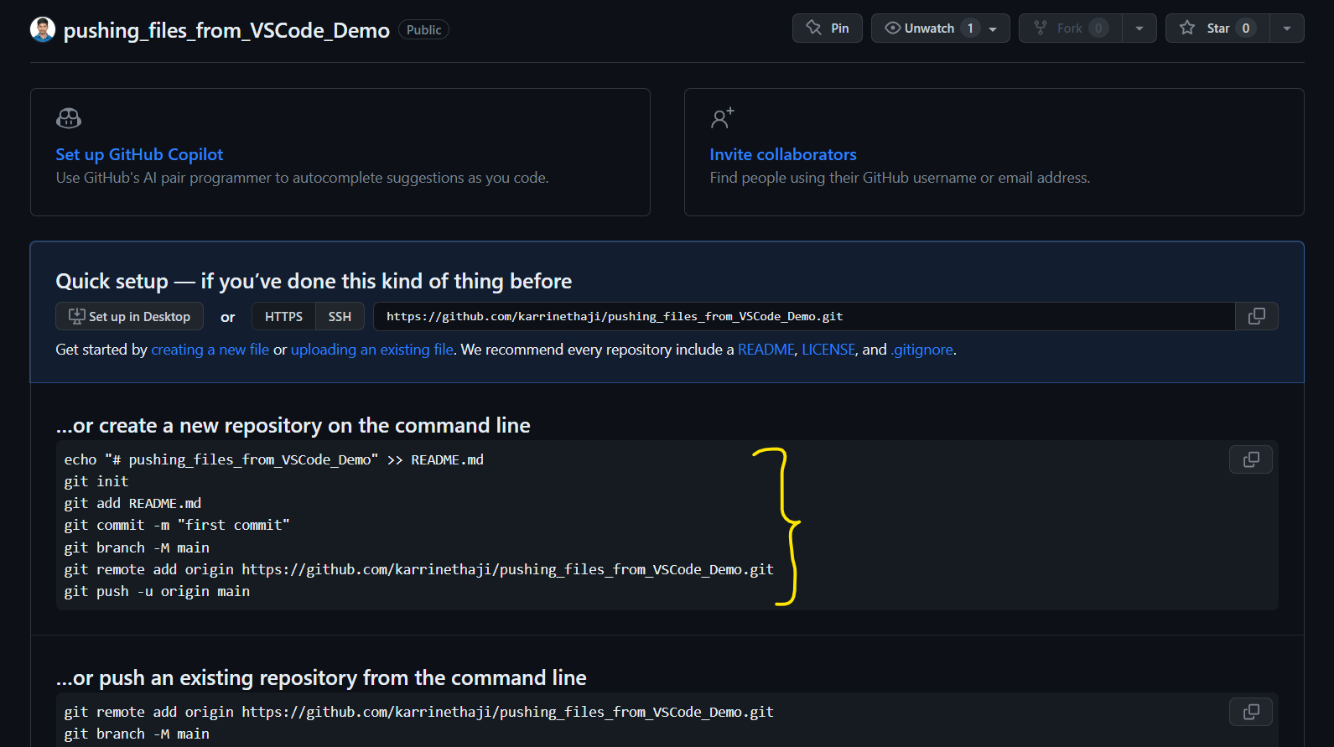

We use the commands which are highlighted in above screenshot to push the files from VS Code to Git hub through terminal.

Pasting the commands here:

create a new repository on the command line

echo "# pushing_files_from_VSCode_Demo" >> README.md

git init

git add README.md

git commit -m "first commit"

git branch -M main

git remote add origin https://github.com/karrinethaji/pushing_files_from_VSCode_Demo.git

git push -u origin main

**Switch to VS Code**: [In PW Skills]

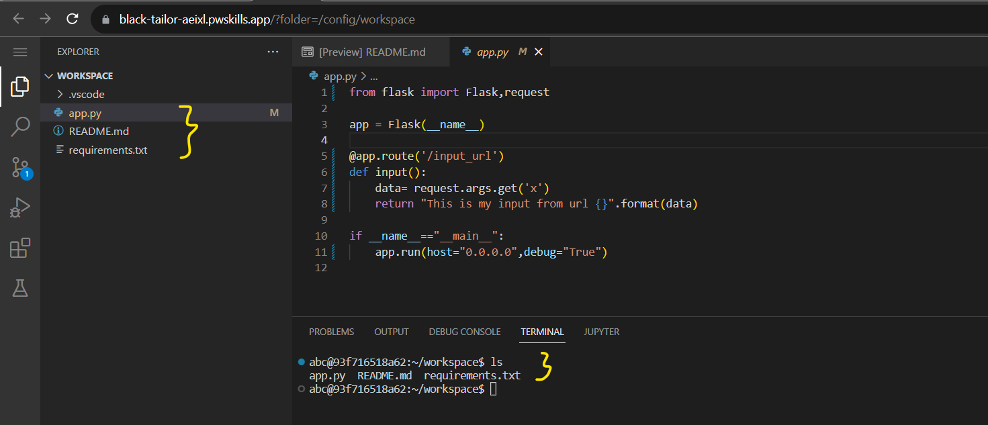

If you want to list out the files which are present under the particular location then use command “ls”

Let’s execute the command one by one to push the files to git hub:

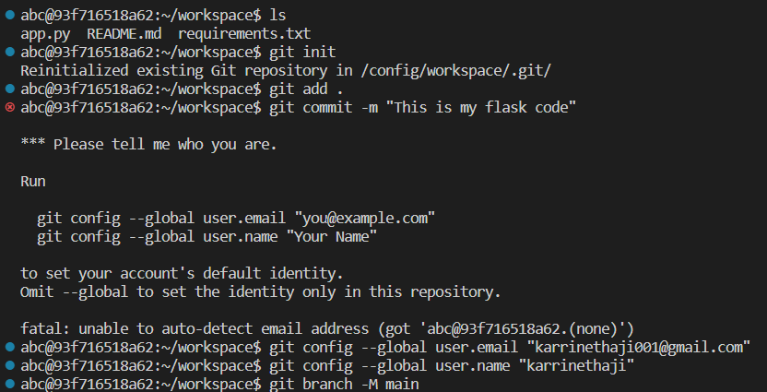

If you are doing push operation for first time then, you need to enter two more commands after “git commit -m “message” to link our git hub account to visual studio code:

* git config –global user.email “<your git hub email>”
* git config –global user.name “<Your Username of git hub account>”

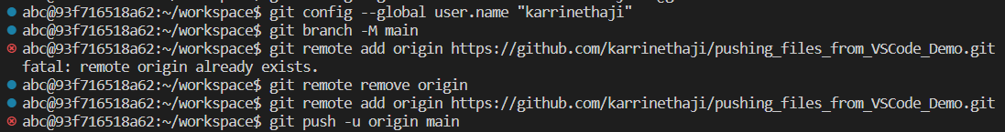

If you have remote origin for the newly created git hub repository then you will get the error “fatal: remote origin already exists”

To remove the error, we need to execute the command “git remote remove origin” then after that again run the command “git remote add origin “git hub path”.

Finally, after entering the command “git push -u origin main” then it will automatically give a pop up.

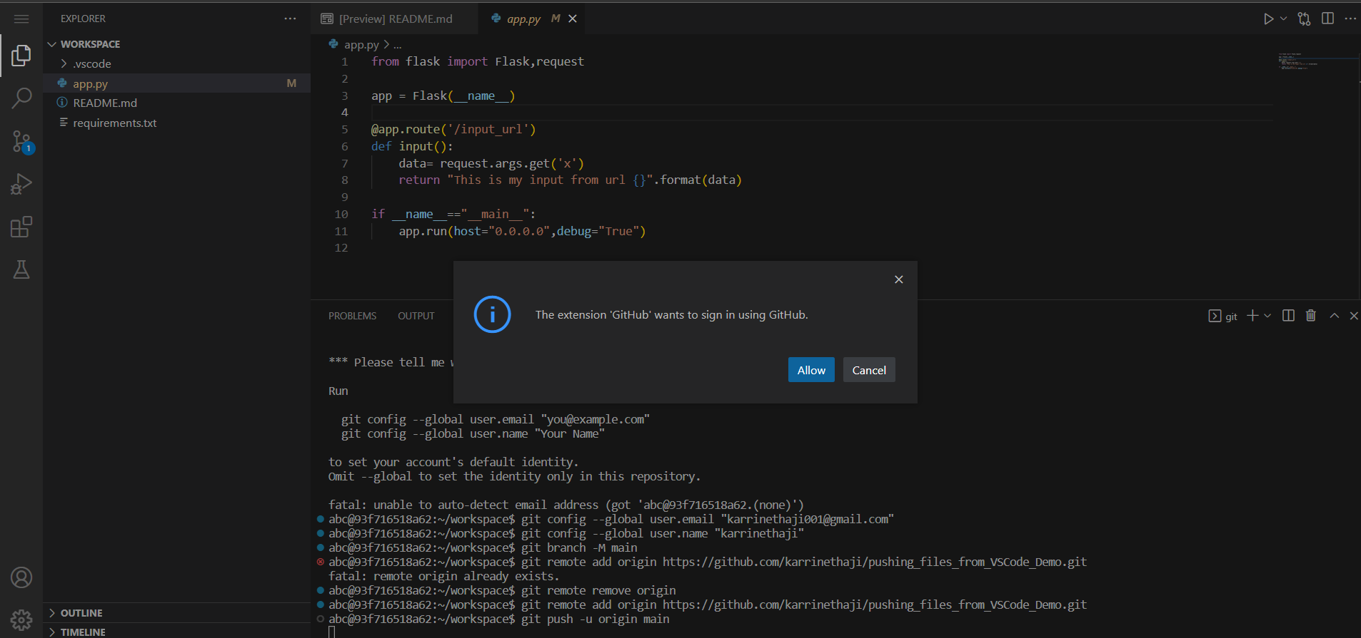

Click on “Allow”

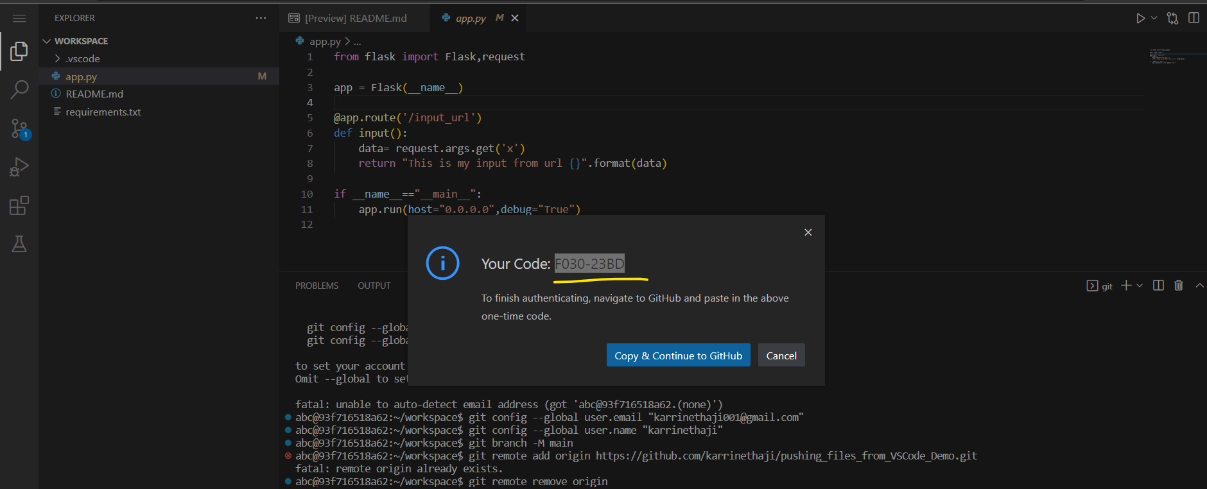

* Copy the above code and click on “Copy & Continue to Git Hub”

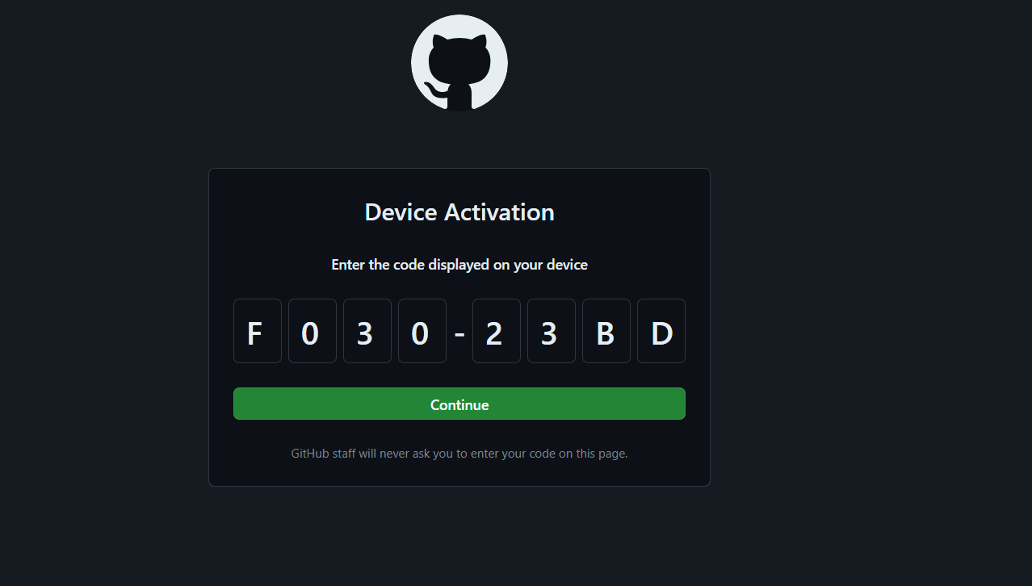

Click on “Continue”

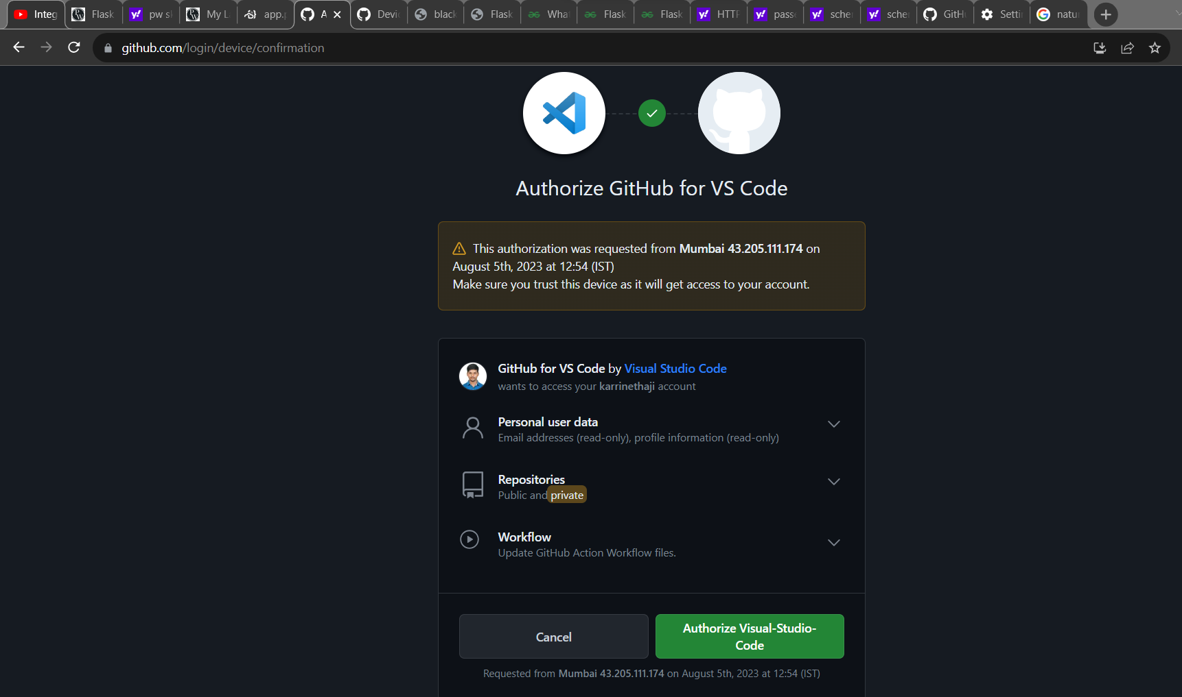

Click on the “Authorize Visual-Studio- Code”

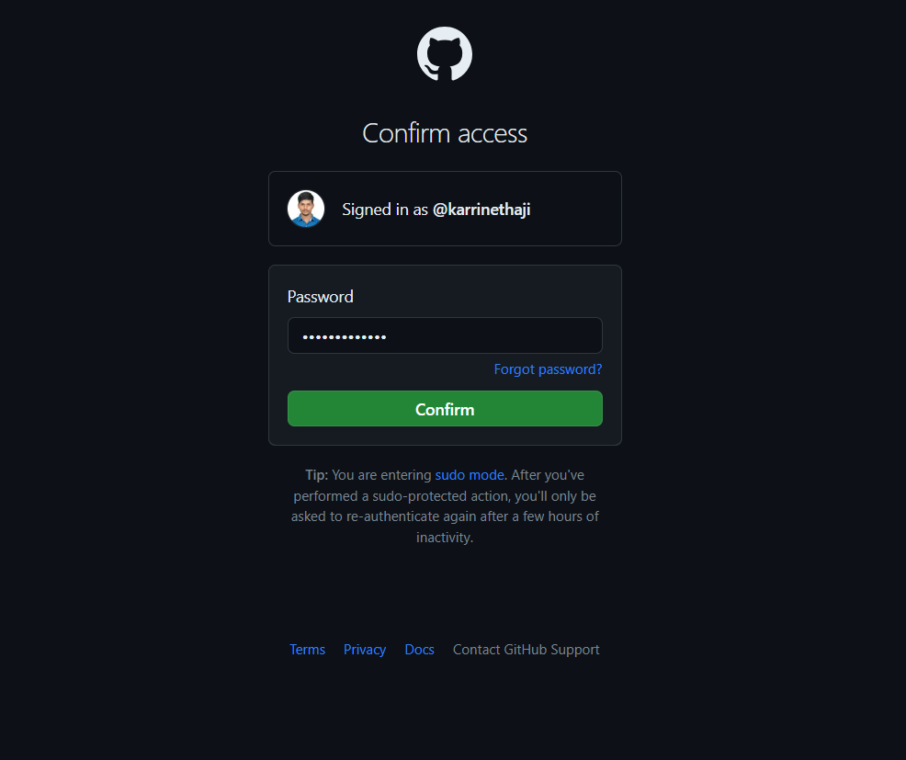

Enter the Password and click on “Confirm”



If you get the congratulations message that means “All the files are successfully pushed into the github repository”.

Let’s switch into git hub account and check whether the files are pushed into the git hub repository or not:

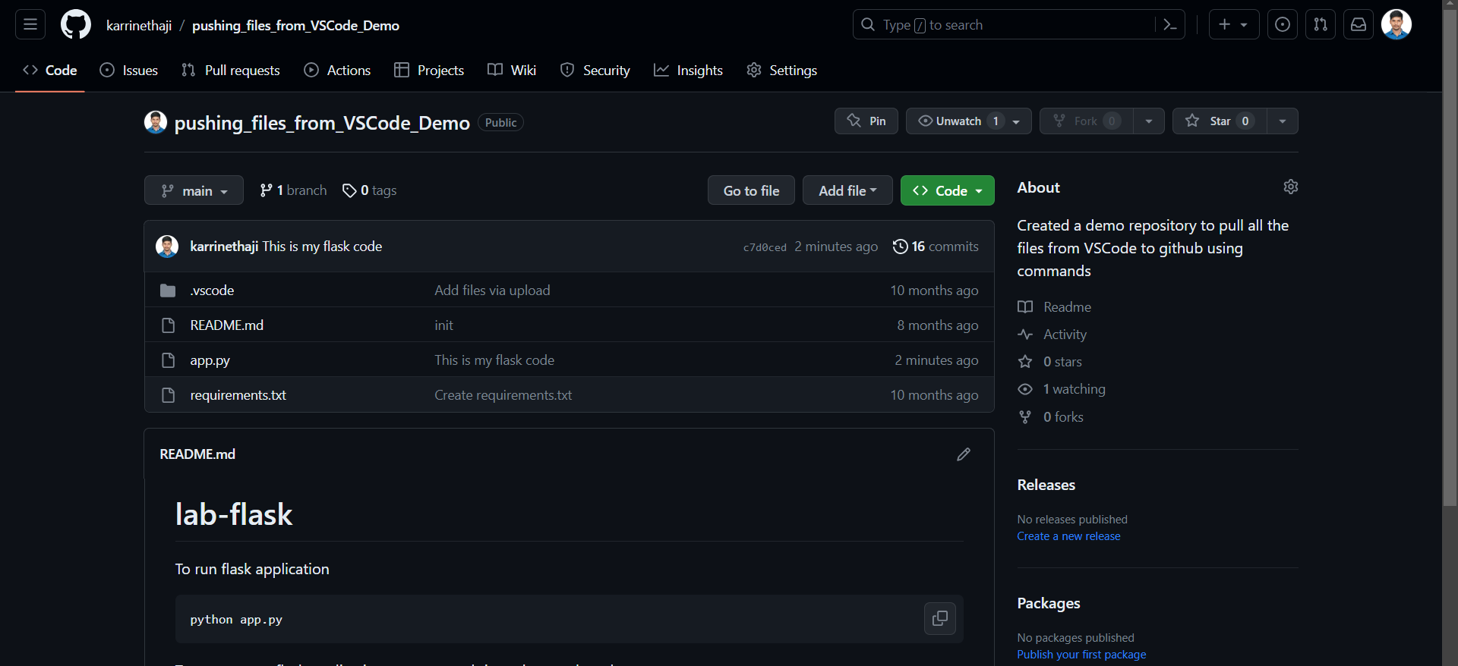

The files are pushed into the git hub repository.

**How to pull or clone the files from Git Hub to VS Code/anything?**

For example, while opening a flask in pw skills, it will ask you whether you want to clone the git hub repository or not.

If you want to clone (getting files from git hub to VS Code) then you need to provide below git hub URL:

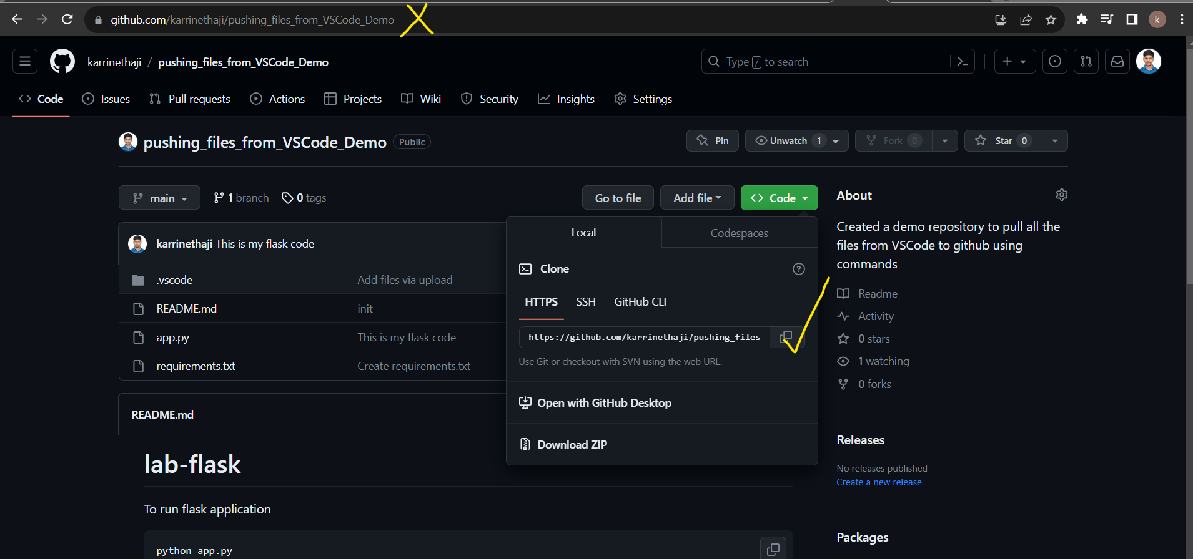

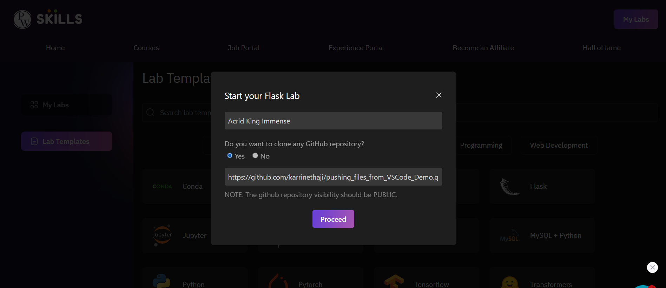

After clicking on “Proceed”, the files automatically cloned into VS Code. PFA screenshot below.

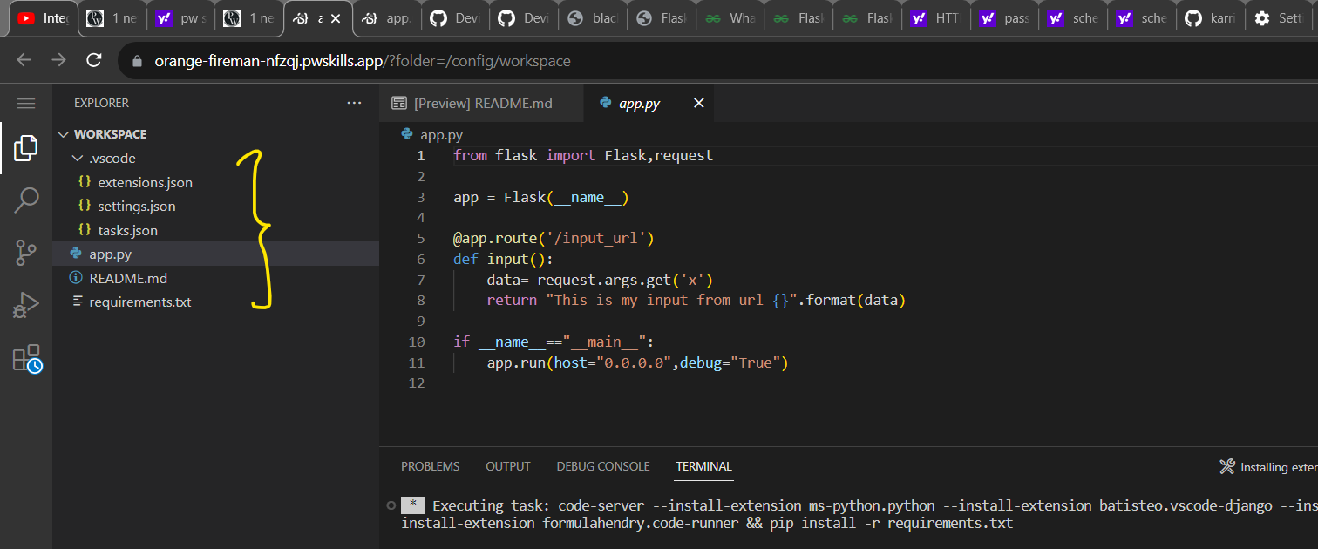

**Clone files using the terminal:**

If you want to clone the files from the terminal then you need to run the below commands:

* git clone <git hub repository url> which is showing in the below picture.



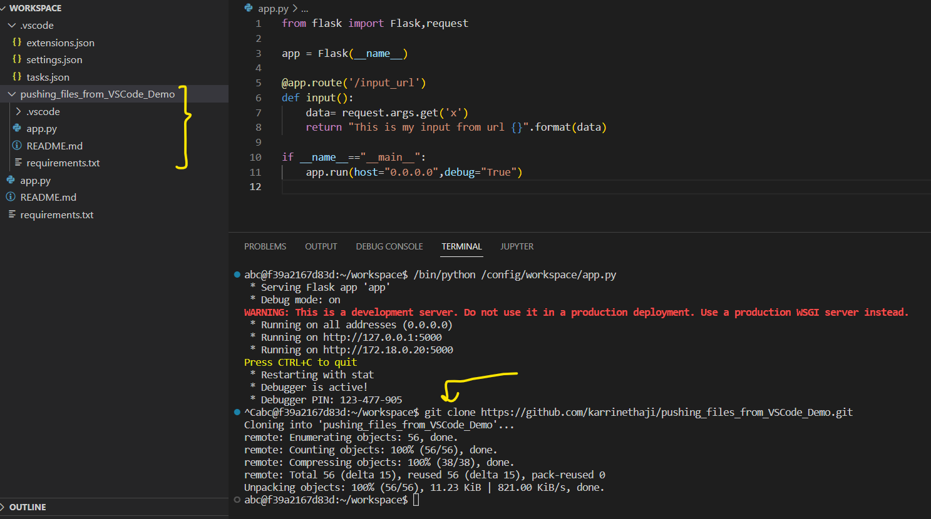

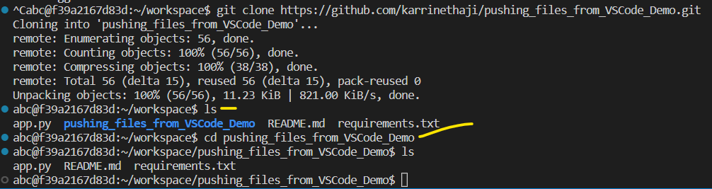

-------------------------------------Done with the Pushing and pulling/clone operations---------------------------------